EC8208 — Software Architecture
QuickEats
Reference Architecture
A model solution for the group exercise — C4-based, with the reasoning made explicit.

This is one defensible design, not the only one. Use it to check your group’s thinking: did you choose a style for a reason (a quality attribute), keep things loosely coupled, and define clear interfaces? Your diagram can differ and still be correct.

1. How to use this document
It walks the same path the exercise asks of you: understand the drivers, draw the system at three C4 zoom levels, justify a style per part, open one container into components with interfaces, then name the patterns and the decisions that hold it together. Section 13 maps each part back to the exercise tasks and learning outcomes.

2. System overview
QuickEats is a city-wide, mobile-first food-ordering and delivery platform that runs across several cities. Customers browse restaurants, order and pay online, and watch their rider approach in real time. Restaurants manage menus and accept or reject orders. Riders pick up and deliver. The operations team runs promotions and reads analytics. Load is highly variable — calm mid-afternoon, intense at meal times — and the platform depends on external payment and mapping providers.

3. Architectural drivers

3.1 Functional requirements
- Browse and search restaurants and menus.
- Place an order and pay online.
- Restaurant accepts or rejects an order.
- Assign each accepted order to a nearby, available rider.
- Track the rider’s location live on a map.
- Notify the customer at each status change.
- Apply promotions and discount codes.
- Provide an operations dashboard and analytics.
- Collect ratings and reviews after delivery.

3.2 Quality attributes — the real drivers
Every style choice later in this document earns its place by serving one of these. Each is written as a concrete scenario, not a vague wish.
Attribute | Scenario | How the architecture responds
Availability | At dinner peak, one failing service must not stop ordering. | Stateless, redundant services; broker buffering; graceful degradation
Real-time | Order status and rider location reach the app within a couple of seconds. | Event streaming + publish/subscribe
Scalability | Peak traffic is many times off-peak and differs per city. | Horizontal scaling; async processing; partitioning
Consistency | An order is never ‘paid but lost’ or ‘delivered but unpaid’. | Single owner of order state; saga + idempotency
Modifiability | A new payment provider or promo type ships without touching unrelated code. | Loose coupling; Strategy; database-per-service
Security | Card data and personal data are protected; only authenticated actions run. | Auth at the edge; TLS; card handling delegated to the gateway

3.3 Constraints & assumptions
- Must integrate a third-party payment gateway and a maps/routing service.
- Mobile-first clients; multi-city, multi-restaurant (multi-tenant).
- Cloud deployment; a mainstream web/service stack the team already knows.

4. Architectural approach
We describe the system with the C4 model — four zoom levels (Context → Container → Component → Code), like zooming a map from country to street. We use the first three. The design is deliberately a hybrid: no single style fits the whole system, so each container uses the style that best serves its dominant quality attribute — a rice-and-curry plate of styles sharing one platform.

5. C4 Level 1 — System Context
The widest view: QuickEats as one box, the four human roles that use it, and the three external systems it depends on.
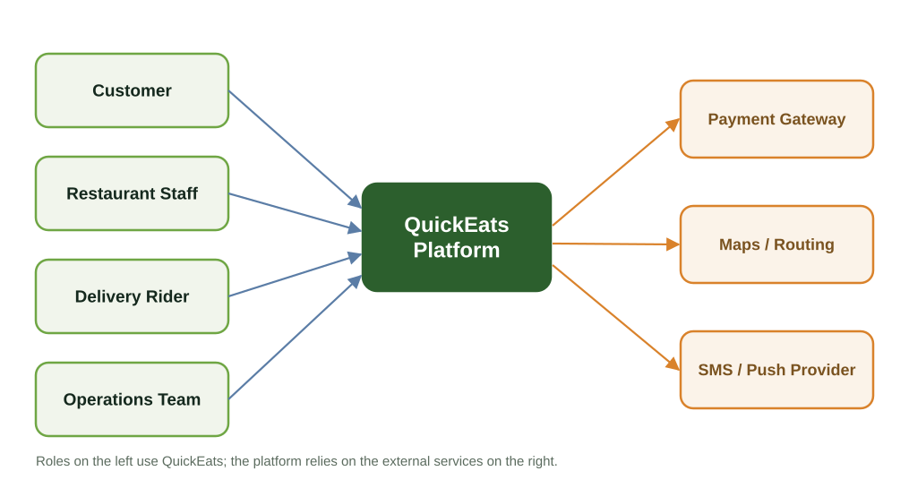
Figure 1 — QuickEats system context (C4 Level 1).
Customers, restaurant staff, riders and the operations team interact with the platform; payment, mapping and messaging are delegated to specialist external providers rather than built in-house.

6. C4 Level 2 — Containers
Zooming in one level shows the deployable pieces — client apps, an API gateway, a set of services, an event bus, and the external systems. Each internal service is tagged with the architectural style it leans on.
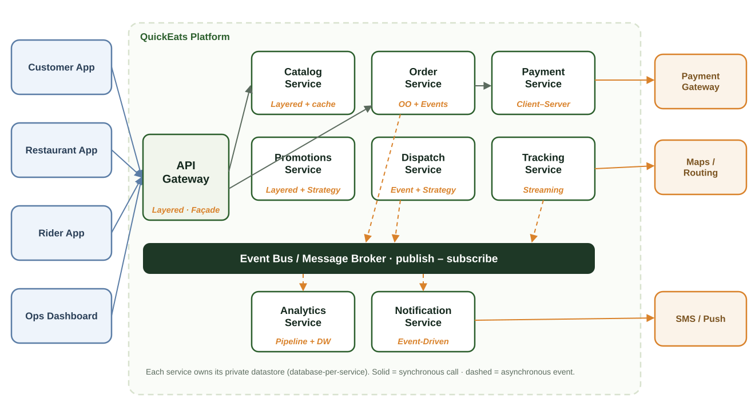
Figure 2 — QuickEats containers and the style each one uses (C4 Level 2).

6.1 Responsibilities and chosen styles
This is the heart of the exercise: a style per container, each justified by the quality attribute it serves.
Container | Responsibility | Style | Why (driver)
API Gateway | Single entry point: routing, auth, rate limiting | Layered + Façade | Security, modifiability
Catalog Service | Restaurants, menus, search/browse | Layered over read-optimised store | Scalability (read-heavy)
Order Service | Owns the order lifecycle; source of truth | OO domain + Event-Driven | Consistency + real-time
Payment Service | Charge / refund via the gateway | Client–Server + Strategy + Façade | Consistency, security
Dispatch Service | Assign orders to nearby riders | Event-Driven + Strategy | Real-time, scalability
Tracking Service | Live rider location and ETA | Event-Driven / streaming | Real-time responsiveness
Promotions Service | Discount codes and rules | Layered + Strategy | Modifiability
Notification Service | SMS / push on status changes | Event-Driven + Adapter | Real-time, modifiability
Analytics Service | Order / delivery metrics & reports | Pipe-and-Filter + Data-Centred | Scalability (offline)

6.2 How the containers communicate
Synchronous request/response is used on the customer’s critical path — browse, place order, pay — where someone is waiting for a definite answer. Asynchronous events over the bus are used for everything reactive — dispatch, live tracking, notifications and analytics. This keeps the ordering path fast while letting the reactive parts scale and change independently. Notably, every service owns its own datastore; no service reaches into another’s database.

7. C4 Level 3 — Component views
Level 3 opens a container to show its components and — the point of the level — its interfaces. In every diagram below, a circle-on-a-stick marks a provided interface (the socket others plug into), a solid arrow a synchronous required call, and a dashed arrow an asynchronous event. We work through the Order Service in full, then give a view of each remaining container.

7.1 Order Service
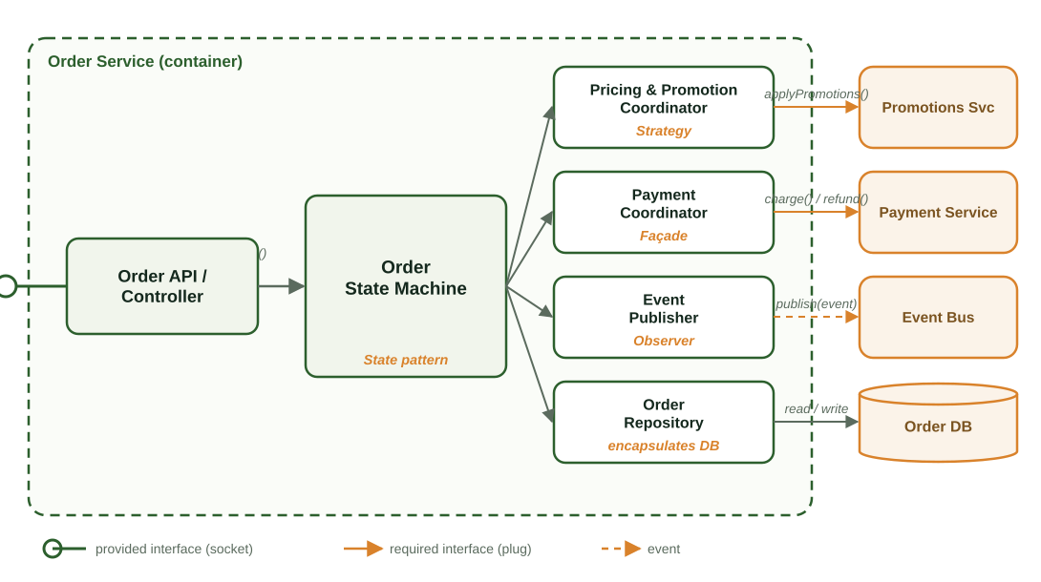
Figure 3 — Inside the Order Service: components and interfaces (C4 Level 3).
Component | Responsibility | Interface / pattern
Order API / Controller | Validates input; exposes the service’s operations | Provided interface (socket)
Order State Machine | Owns the lifecycle: created → paid → accepted → picked-up → delivered / cancelled | State pattern; high cohesion
Pricing & Promotion Coordinator | Computes price and applies promotions | Requires Promotions (Strategy)
Payment Coordinator | Initiates charge / refund | Requires Payment (Façade)
Event Publisher | Emits OrderCreated / Accepted / … | Observer / pub-sub
Order Repository | Loads and stores orders | Encapsulates the Order DB

Provided interface (the socket): placeOrder(cart, customer) → orderId and getOrder(orderId). The customer app plugs into this and neither knows nor cares what happens inside.
Required interfaces (the plugs): applyPromotions(cart), charge(orderId, amount) / refund(…), publish(event), and read/write to the order store. Swap the provider behind any of these and the Order Service is untouched.

7.2 Catalog Service
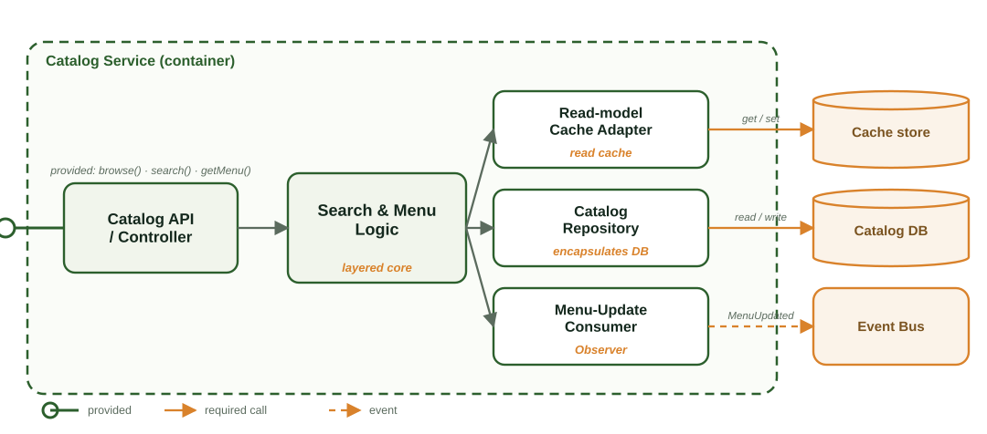
Figure 4 — Catalog Service components (C4 Level 3).
Browse and search are read-heavy, so the API sits over a layered core that reads through a cache (a read-model) and falls back to the repository. A consumer keeps the cache fresh from MenuUpdated events. Provided: browse(), search(), getMenu(). Required: the catalog database, a cache store, and the event bus.

7.3 Payment Service
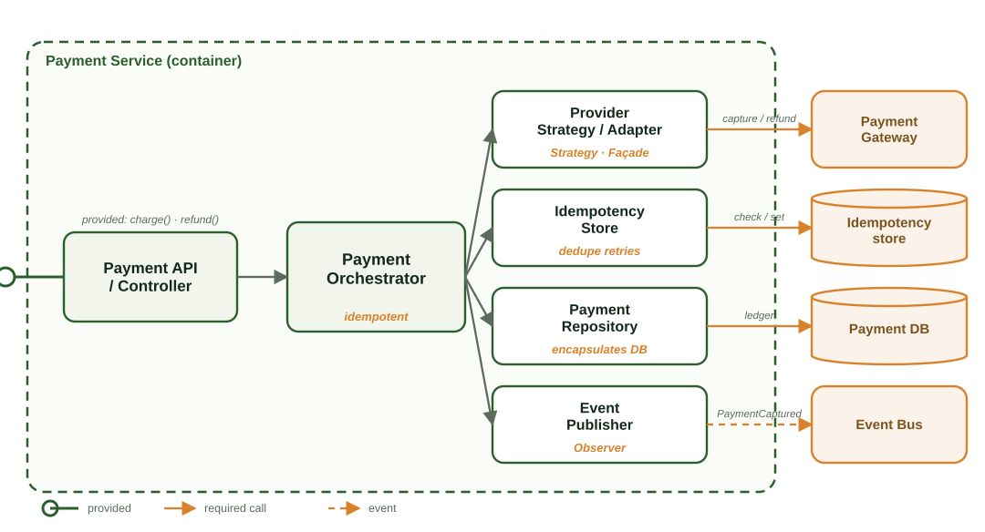
Figure 5 — Payment Service components (C4 Level 3).
The API delegates to a Payment Orchestrator that is idempotent (safe to retry). A Strategy/Façade adapter hides whichever external gateway is in use; an idempotency store dedupes retries; the repository keeps an immutable ledger; an Event Publisher emits PaymentCaptured. Provided: charge(), refund(). Required: the payment gateway, the event bus, and its stores.

7.4 Dispatch Service
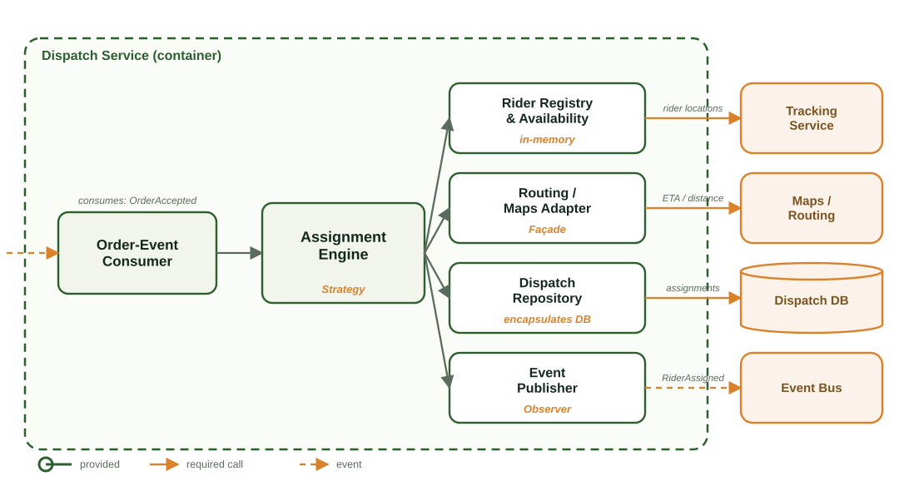
Figure 6 — Dispatch Service components (C4 Level 3).
Event-driven: it consumes OrderAccepted, then an Assignment Engine (Strategy — nearest / load-balanced / ETA-optimised) picks a rider using live locations from Tracking and distances from Maps, records the assignment, and publishes RiderAssigned. Required: Tracking, Maps/Routing, the event bus, and its database.

7.5 Tracking Service
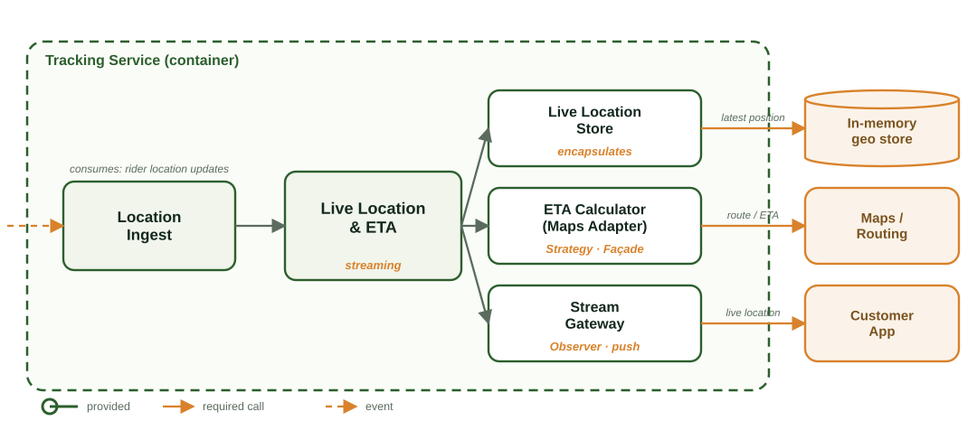
Figure 7 — Tracking Service components (C4 Level 3).
High-frequency rider positions stream in and update a fast in-memory store; an ETA calculator (a Maps façade) enriches them; a Stream Gateway pushes live updates to the customer app (Observer). It mostly consumes events and pushes, rather than answering synchronous calls. Required: Maps/Routing and the customer push channel.

7.6 Promotions Service
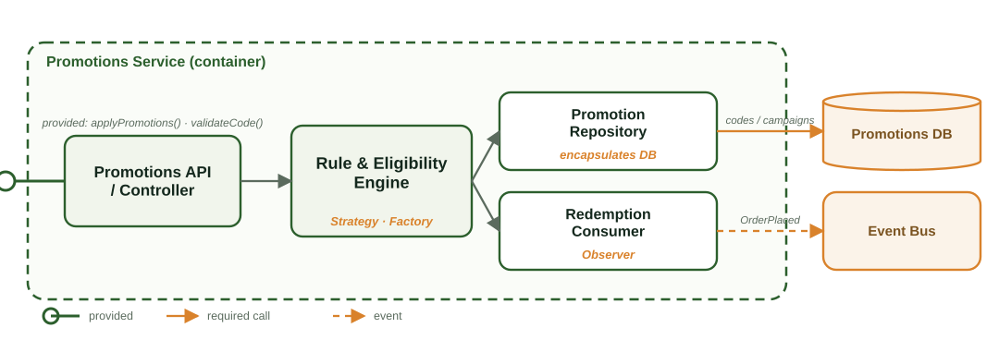
Figure 8 — Promotions Service components (C4 Level 3).
A Rule & Eligibility Engine applies pluggable promotion types (Strategy, built via a Factory) and checks usage limits; a repository holds codes and campaigns; a consumer tracks redemptions from order events. Provided: applyPromotions(), validateCode(). Required: its database and the event bus.

7.7 Notification Service
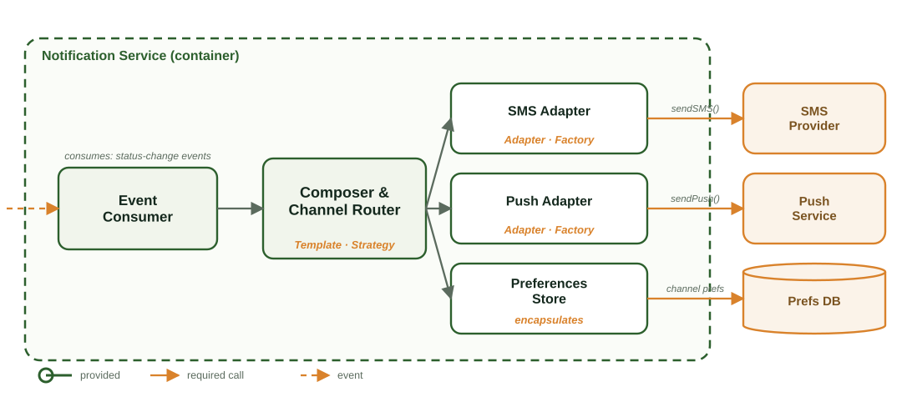
Figure 9 — Notification Service components (C4 Level 3).
A subscriber to status-change events composes a message (template + Strategy) and routes it to a channel. Channels are swappable Adapters built by a Factory — add email tomorrow without touching the core. Required: the SMS and push providers, and a preferences store.

7.8 Analytics Service
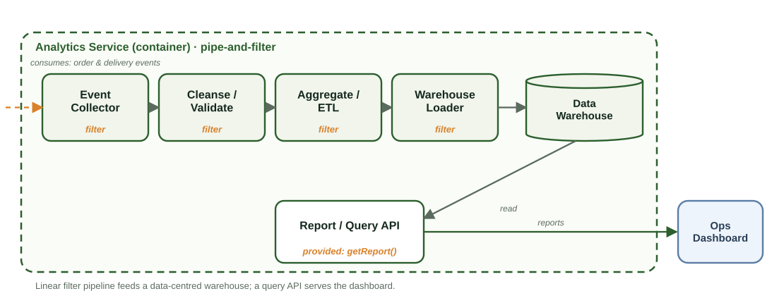
Figure 10 — Analytics Service components (C4 Level 3).
A classic pipe-and-filter: collect → cleanse → aggregate → load into a data-centred warehouse, then a query API serves the operations dashboard. It is offline and batch-friendly, so it scales independently of the live ordering path. Provided: getReport(). Required: the event bus (as a source) and the warehouse.

7.9 API Gateway
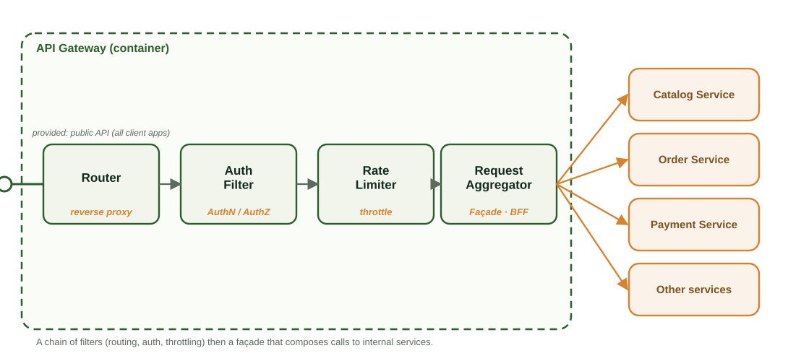
Figure 11 — API Gateway components (C4 Level 3).
A chain of filters — routing, then authentication/authorisation, then rate limiting — followed by a Façade / BFF aggregator that composes calls to internal services. It is the one place to enforce security and shield the inside from clients. Provided: the public API. Required: the internal services.

8. Component-level design principles applied
Principle | How it shows up in QuickEats
High cohesion | Each component has one reason to exist: the Payment Coordinator only orchestrates payment; it never prices the cart.
Loose coupling | Components depend on interfaces, not implementations; services talk over the bus and never touch another service’s database (database-per-service).
Encapsulation | The Order Repository hides the storage choice; the Payment Coordinator hides the external gateway’s quirks behind charge().
Separation of concerns | Ordering, payment, dispatch, tracking, notification and analytics are separate containers, each free to evolve and scale on its own.

9. Design patterns applied
Pattern | Where in QuickEats | Why
Observer / Pub-Sub | Order events → Dispatch, Tracking, Notification, Analytics | Publish once; many independent reactors; add a subscriber without changing the publisher
Strategy | Payment provider; rider-assignment algorithm; promotion rules; ETA model | Swap the method without touching callers
Factory | Build the right channel adapter or payment-provider object from config | Centralise creation; no scattered ‘new ProviderX’
Façade | Payment Service over the gateway API; a Maps façade over routing | One clean call hides a messy subsystem
Adapter | SMS / push channel adapters; the payment-gateway adapter | Make an incompatible external API fit a common interface
State | The order lifecycle | Make illegal transitions impossible; keep transition rules in one place

10. Key architectural decisions
The decisions that are hard to reverse — each with its trade-off stated, because every architectural choice costs something.
ID | Decision | Rationale | Trade-off
AD-1 | Event-driven backbone for reactive flows | Decoupling, real-time fan-out, independent scaling | Eventual consistency; the broker is critical infrastructure
AD-2 | Database-per-service (no shared DB) | Loose coupling; independent scaling and schema change | Cross-service queries need composition / CQRS
AD-3 | Synchronous payment, asynchronous everything else | The customer needs an immediate paid/failed answer; the rest can react | Payment latency sits in the order path
AD-4 | Read-optimised catalog (cache / replica) | Browse traffic is read-heavy and spikes at peak | Cache invalidation; menus may be stale for seconds
AD-5 | Saga + idempotency for order ↔ payment | Consistency across services without distributed locks | More moving parts; compensating actions to design
AD-6 | Strategy-based pluggable algorithms | Modifiability for payments, dispatch and promos | A little more indirection

11. Cross-cutting concerns
- Security: authentication and authorisation are enforced at the API Gateway; TLS everywhere; card data is never stored — it is delegated to the PCI-compliant gateway; services run with least privilege.
- Availability & scalability: stateless services scale horizontally; the broker absorbs spikes; non-critical features such as live tracking degrade gracefully under extreme load.
- Consistency: the Order Service is the single owner of order state; payment uses a saga with idempotent operations so retries are safe.
- Observability: structured logs, metrics and distributed tracing follow each order across services and events via a correlation ID.

12. Pitfalls this design avoids
- No God service — responsibilities are split by concern, not piled into one.
- No shared database — avoids the hidden coupling that turns services into a distributed monolith.
- Not one-style-for-all — synchronous where the user waits, event-driven where things react.
- Not over-engineered — patterns appear only where they remove real pain.

13. How this maps to the exercise & outcomes
Exercise task | Where it’s answered here | Learning outcome
1 — Context + Container | Sections 5 and 6 (Figures 1–2) | LO-3 architectural styles
2 — A style per container | Section 6.1 (table) | LO-3 choosing by quality attribute
3 — Zoom into one box | Section 7 (Figure 3 + interfaces) | LO-4 component-level design
4 — Pick a pattern | Section 9 (patterns table) | LO-5 design patterns

Remember the test for a good answer: every style choice is tied to a quality attribute, containers are loosely coupled, interfaces are explicit, and the design is a sensible hybrid rather than one style forced everywhere.

